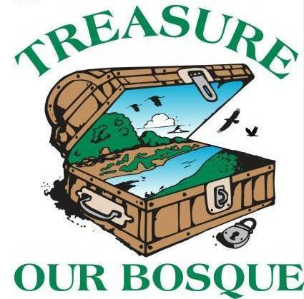
Save Our Bosque Task Force Board Meeting
Socorro County Annex Office
198 Neel Ave.
Socorro NM

Tuesday, Sept 1 @ 3:00pm
Meeting Location: Zoom call
In attendance: Gina Dello Russo, Yasmeen Najmi, Matt Mitchell, Amy Erickson, Abigail Plecki, Kathy Granillo, Stephanie Roussel, Rex Myers, Sarah Anderson, Renee Roubichaud, Sandra Noll, Jerry Wheeler
Meeting began at 3:03pm
1. Approve Agenda – Matt motioned, Sandra second, approved

2. Approve Minutes from August meeting – Matt motion to accept August minutes, Yasmeen second, passed.

3. Action Items:

- Sarah will let Amy know which projects have updates for next month’s agenda
- Sarah will send the budget spreadsheet to board members before each meeting
- Sarah will send Stephanie R. information on our CRP update and protocols for veg monitoring
- Sandra will get Matt in touch with Colin about setting up a PayPal link
- Yasmeen will keep us updated about the guardrail repair at the riverine parks
- Amy swill send out the membership drive materials to the board
- All – provide comments to Amy or Sandra about the membership drive documents.
- All – Please send Sarah a post for the Facebook page so we can keep everyone engaged in our work. We would like to have a post from each board member
- All – Send Amy or Sarah calendar items to put on our website calendar.

4. Treasurer’s Report
Matt gave the treasurer’s report. The balance as of today is $20,877.00. Yasmeen had some questions about the BOR grant – this grant covers Sarah’s work monitoring and reporting on BOR’s habitat restoration projects around Socorro. It also pays for some of the intern’s salary and truck rental. It is a reimbursable grant and most of the work takes place in the summer/fall.

5. Fundraising update
MRGCD -
The MOU has been completed and signed by Gina and Mike Hammond. The MOU outlines the general scope of work and agreed upon cooperative activities and projects (in particular tasks for Sarah). The board approved the MOU. Sarah has submitted one invoice so far.

City of Socorro –
Not much to report since last time. Sarah purchased a couple more things for the parks and we have around $1,000 left in the budget. We still have to purchase a power washer. Sarah asked about the city hosting workday to install the new grills and picnic tables, but has not heard back.

Current grant applications-
One grant with FAWRA is still in the hopper. We will work with State Forestry to help them move forward on the NMDGF/Escondida bosque restoration project. Abigail (State Forestry) has been working with Sarah regularly on these grants. We are also looking at a WaterSmart landscape restoration grant, which could be a partner project with MRGCD.

Membership drive –
Sandra and Amy developed final language and giving levels for the membership drive. We are also working on a new SOBTF logo. Matt will work with Colin to get the PayPal link set up.

6. Community Outreach
All community events are postponed until further notice. The current regulations are no groups larger than 10. Matt is still working with the schools to see if they want to do a virtual Bosque Conservation Day, but has not heard anything back yet.

7. Advocacy
No updates.

8. Project Updates

BOR cooperative agreement – fiscal year for BOR ends Sept 30th. Sarah is finishing up field work and woody veg surveys. She will write a report and an adaptive management plan.

Tiffany Fire – funding for the Task Force ended on August 10. There is still some private lands work to do and Sarah is coordinating with Abigail to get that done. Abigail mentioned that State Forestry is waiting for the contractor to get back on the site and finish up a final unit, and then they will start spraying saltcedar resprouts on the private land.

WaterSmart Grant – We found some extra money (~$6500) that needs to be spent by the end of this month so Sarah is working with Tetra Tech to create additional maps and outreach materials.

NMC grant – Sarah and Jerry are coordinating the next part of this project (Johnny Pack, whose property borders Mandeville on the north. The Mandeville project was completed earlier this year). Jerry is waiting to receive an updated price agreement.

Kathy – Sevilleta has filled the heavy equipment operator position. Peter Miranda, who currently works at WSMR, will start on October 13.

Partners for Fish and Wildlife Barclay property – Gina, Sarah and Sandra wants to take the landowners on a tour of BdA to talk about potential projects. Sara is going to develop a work plan within the next couple of months.

9. Other
Sandra said community members have been doing a good job keeping the parks cleaned up. Rex walked the trail today and said there was still some trash around Otero Park. The city dump will take trash picked up at the park at no cost. Thank you to the volunteers for keeping the parks and trails clean.

Gina and Sara spoke with Ancestral Lands about the internship program. They discussed suggested improvements on reporting, improving outreach to get more applications, modifying the screening and selection criteria, etc.

10. Adjourn
Sandra moved and Jerry second. Passed. Adjourned at 4:04 pm

Next meeting will be Tuesday, October 6th at 3:00pm.

